# 91880 - L1 Web Development Evidence

### Wire Frame Initial Colours

To begin, I used pixabay to find a public domain image that related to books that would look good on my page. I then tried …

|  |  |
| --- | --- |
| [Tool 1: Palette FX](http://www.palettefx.com/) | [Tool 2: Canva.com](https://www.canva.com/color-palette/) |
|  |  |

I used the palette generated ….

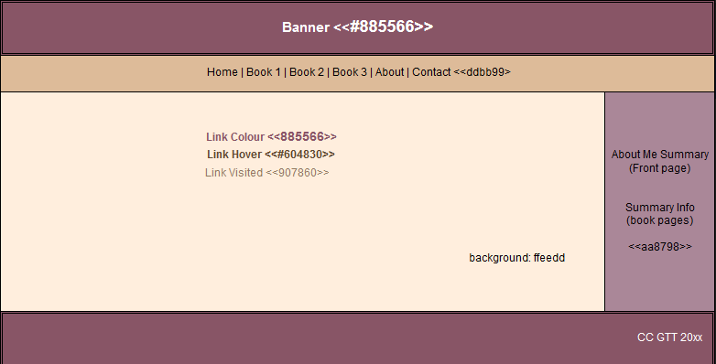

I laid out the site and realised that putting an image at the top left improved the design…

### Refinements…

When I first created the page, the links in the sidebar were hard to read. I fixed ……

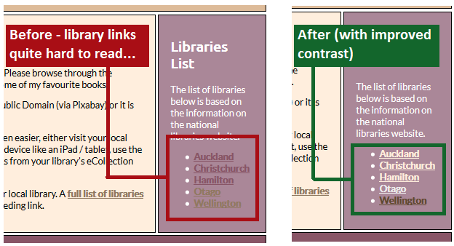

When I first inserted the logo, the 20px padding resulted in an unattractive border and on wide screens, a large purple area appeared on the right hand side. Here is how I refined the logo to address these issues…

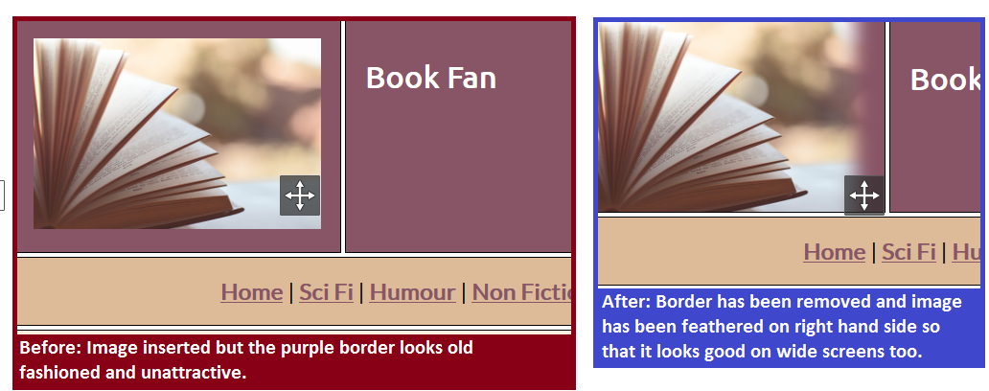

Initially the design looked quite boxy / dated. To fix this, I experimented with the .css and …..

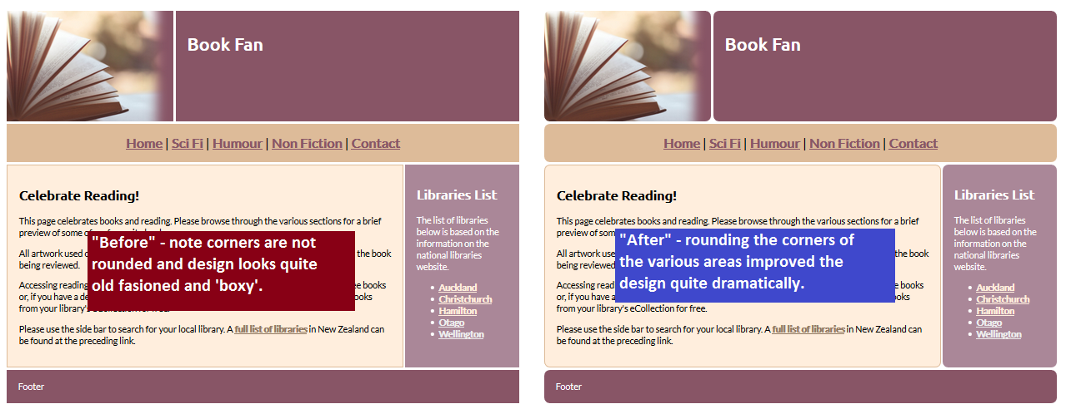

To allow users to find their local library easily I implemented a searchable list using javascript (taken from [W3C schools](https://www.w3schools.com/w3js/) and adjusted very slightly). I put in both a search box and the option to show main centers / all libraries….

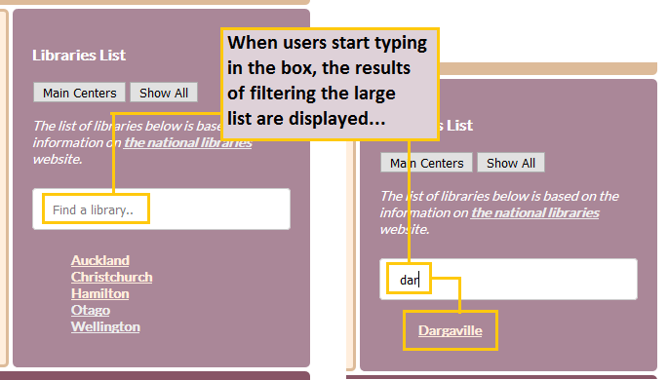

### Contact Page Sidebar

The sidebar looked really plain so I added an image….

|  |  |  |
| --- | --- | --- |
|  |  |  |
| Square (0px) | Rounded (25%) | Circle (50%) |

I showed the option to my friends and they all agreed that the circle image was the best choice.

### Contact Form…

This element took a significant amount of development….

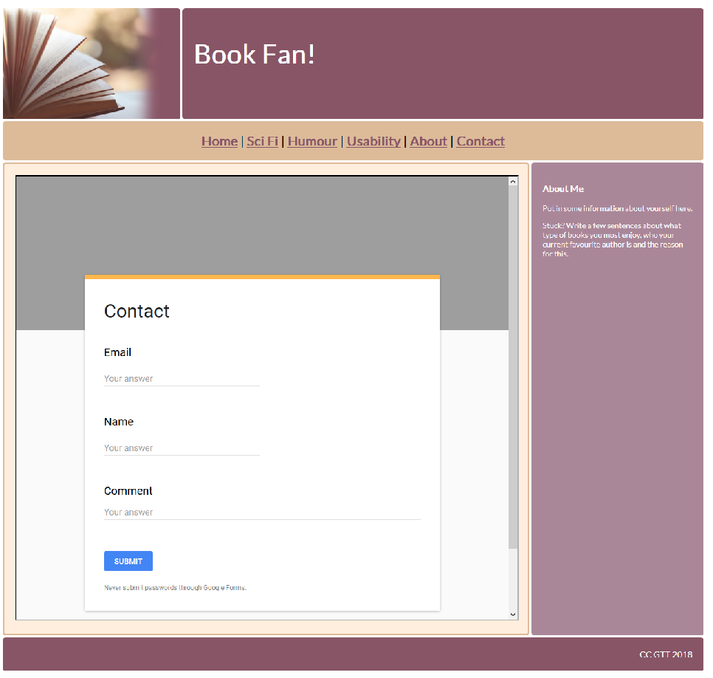

Not only is the a lot of wasted space at the top of the page, for some reason there is an ugly orange line at the top of my form.

I tried putting in an image that was consistent with my page’s theme…

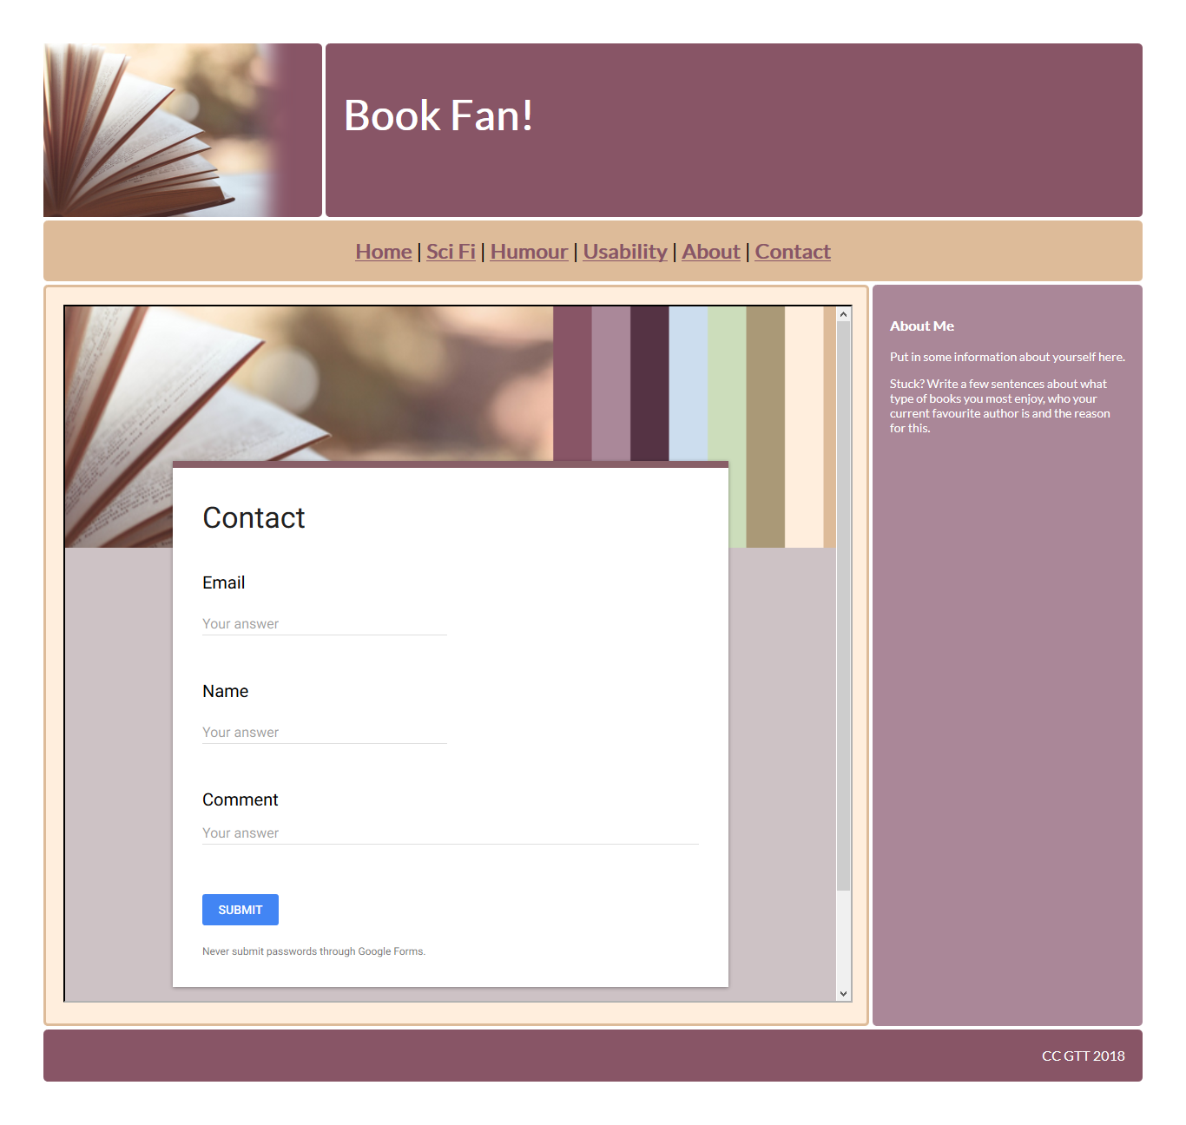

This is a bit better but now we have the book image twice …..

|  |  |
| --- | --- |
|  |  |

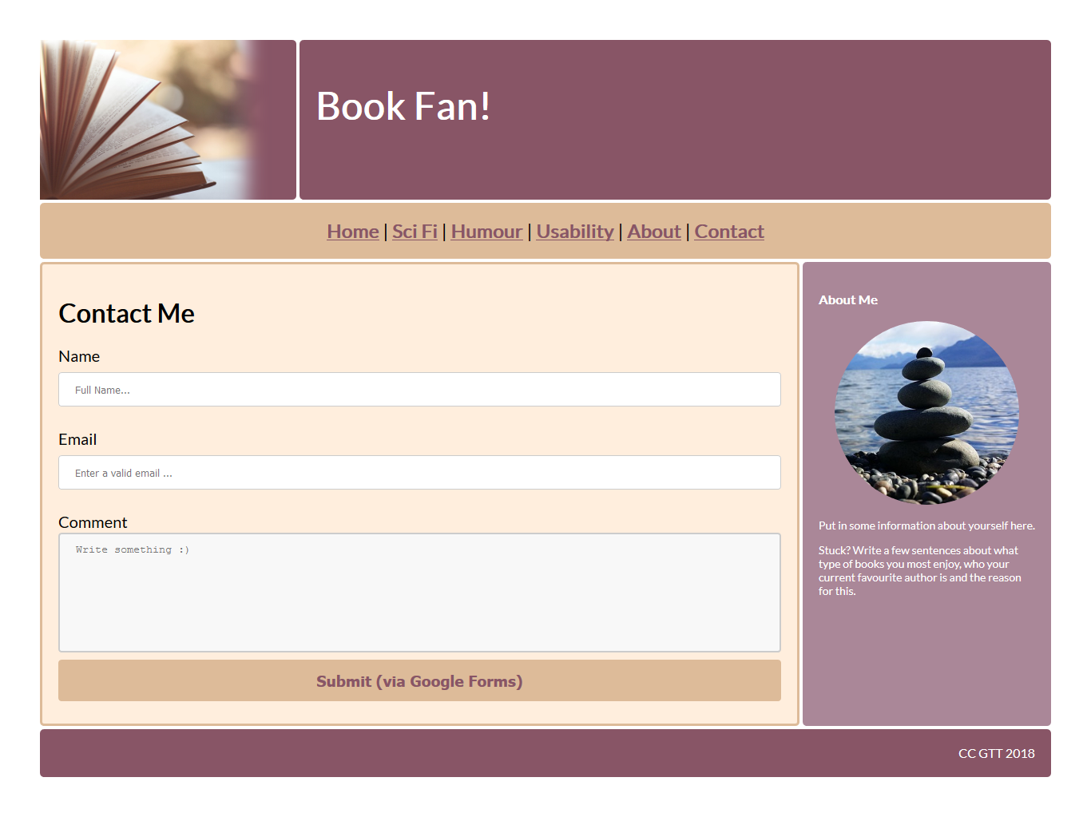

Here is the success page that goes with the form above…

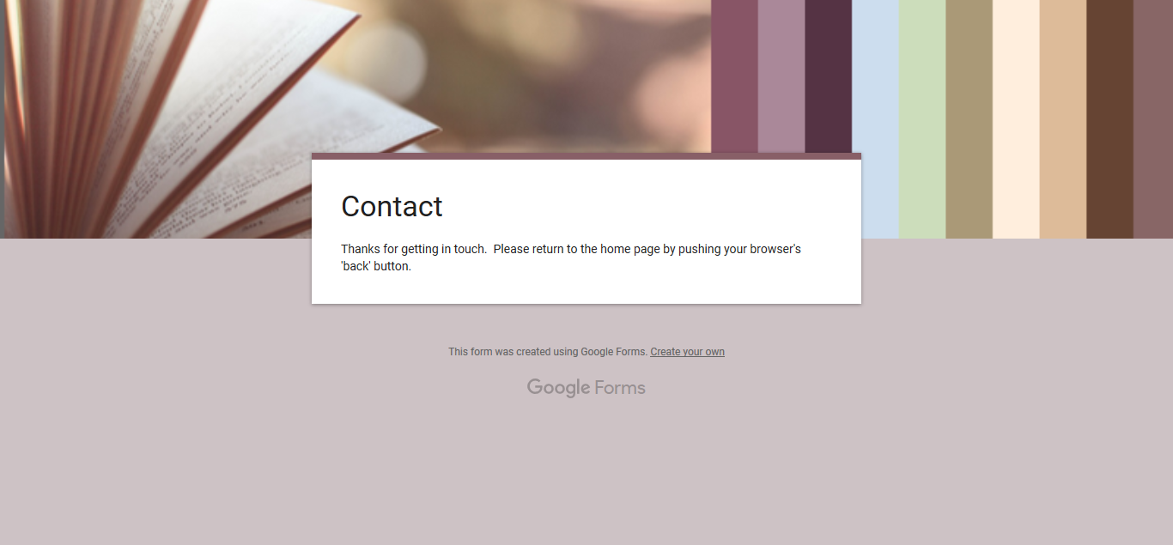

### Review Pages

Below is a screenshot showing how I refined the layout of my review pages.

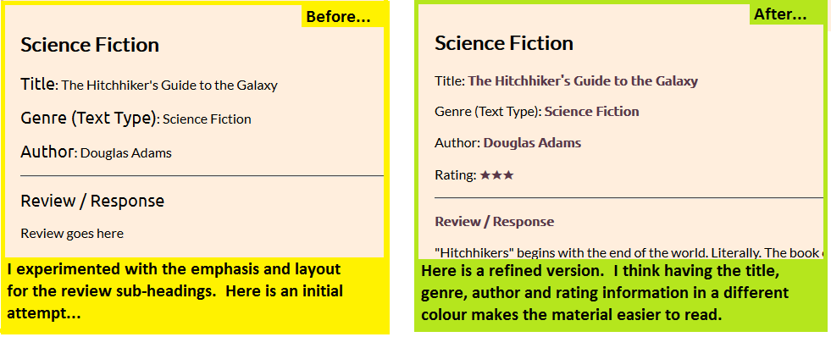

### 

### Further Refinements

* I removed the ‘About’ page as the ‘about’ information has been placed in the sidebar on the contact page….

### Copyright Notes

Initially I had pictures of the book covers for the books that I read on the side bar of each review I emailed Auckland Libraries and asked what the situation with using book covers / copyright was as they use book covers on their site and they told me that they pay a fee for that service which gives them permission to use the material. Here is a quote from the email I received in response to my question about book covers and ‘fair use’

|  |
| --- |
| *“I have taken some advice on the issue of copyright/ IP as it relates to the images of book covers on a website.*  *In our case (*[*www.aucklandlibraries.govt.nz*](http://www.aucklandlibraries.govt.nz)*), the images that you see on the catalogue are supplied by the publishers, who are the copyright owners of the book covers. We pay a subscription to a global company called Syndetics (which is an enrichment service that integrates with our catalogue) and they provide premium cover images to us. So, because we pay for licensed content, our use of these images would be different to that of a school or a student.*  *Our advice would be to check with the publishers. They may be sympathetic to the students’ needs, especially if the images are clearly attributed and they are to be used on a project that will have a finite lifespan.”*  ***Alison Fitzpatrick, Senior Librarian Auckland Libraries, personal communication*** |

I also emailed Copyright Licensing New Zealand (<http://copyright.co.nz/>) and it turns out that the situation regarding copyright and book covers is complex. Below is the answer I received…

|  |
| --- |
| Before I detail a response to your question, I must state that this is not legal advice. CLNZ has a lot of experience in dealing with copyright in the publishing world but can only provide guidance not a legal opinion.    A book cover is a visual artwork. As such, each book cover is an entire work in relation to copyright and copying entire works is, more often than not, an infringement of the rights of the creator of the work. There are exceptions to the exclusive rights that the creator of a work (book, music, film, video game etc) has. In NZ law, these exceptions are known as fair dealing (fair use is an approach used in other countries, most notably the USA). There is a fair dealing exception for **criticism and review**. The following is an excerpt from a guide that CLNZ provides to NZ publishers and authors:    *Fair dealing for criticism or review purposes allows a person to copy certain copyright material when they are critiquing or reviewing that material, for example when writing a book or film review. Some courts have also accepted that protection can extend to criticism of the ideas to be found in a work and its social and moral implications. A fair dealing for criticism or review must be accompanied by a “sufficient acknowledgement”. This generally means that the author and the title of the work are acknowledged.*  ***Paula Browning, CEO Copyright Licensing NZ, Personal Communication*** |

One further refinement was the addition of a drop shadow (via css) as the original images looked a bit flat. Here’s a screenshot showing the improvement.

Below is are the results of experimenting with drop shadows. The third option was the best choice…

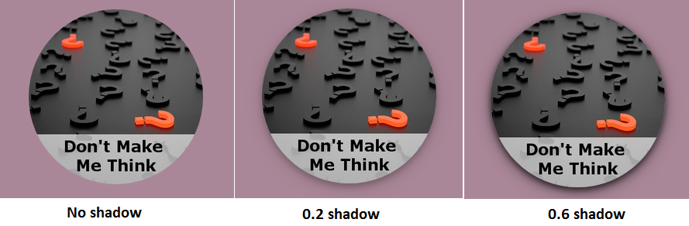

### Testing

I tested my css and the html for all of the pages of the site and can confirm that they validated. I also previewed the site both in Firefox / Chrome and Edge (see screenshots below).

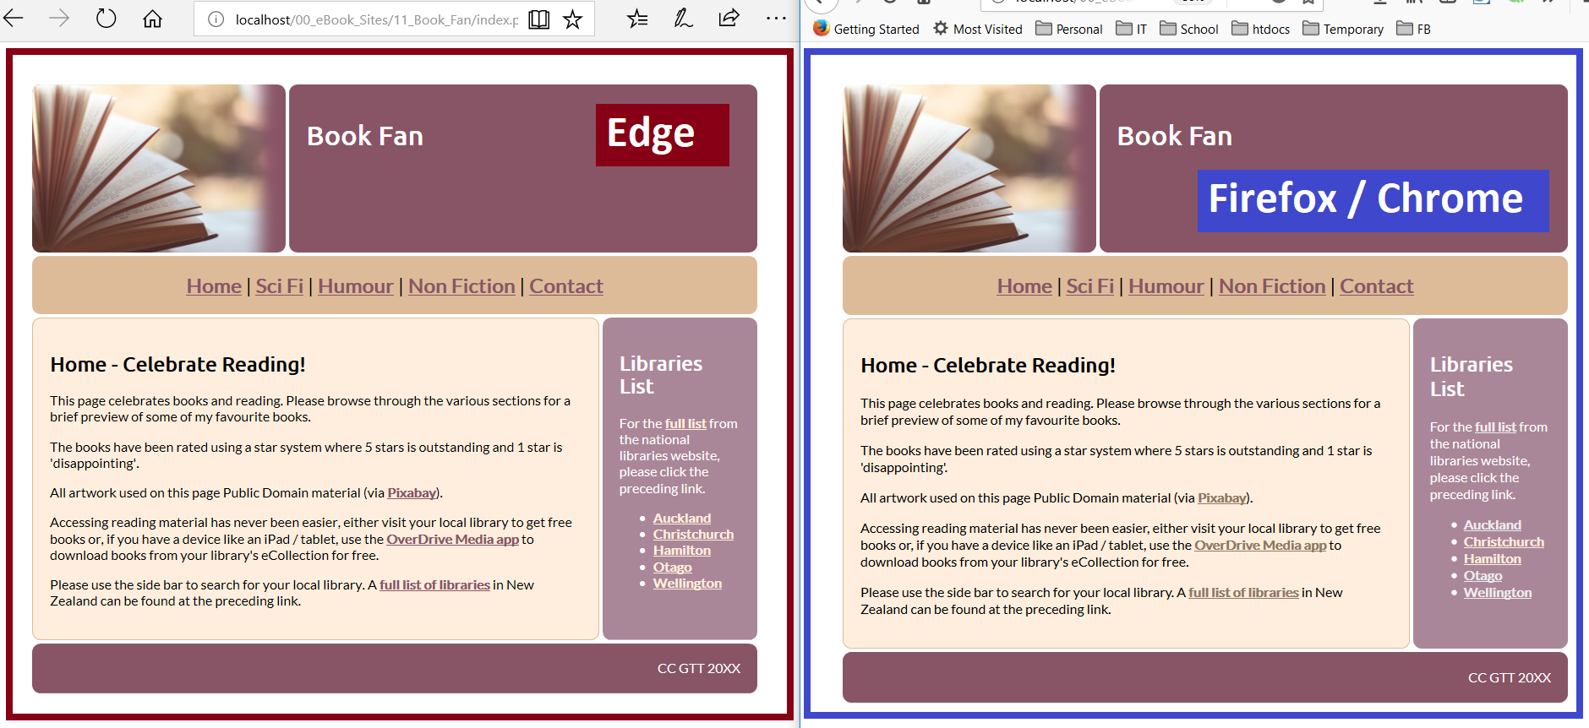

### Usability Testing

I asked my father to try and use my site to check that it was easy to use. Below are the issues that he identified…

* The link to the full list of New Zealand libraries should appear both in the main page and on the sidebar

**Positives**

* Dad found the site easy to read and was generally positive about the layout
* He found the contact page really easy to use

In addition, I realised that the logo on most web pages links back to the home page so I edited my site ….

Here are some ‘before’ and ‘after’ screenshots showing that the issues identified above have been resolved

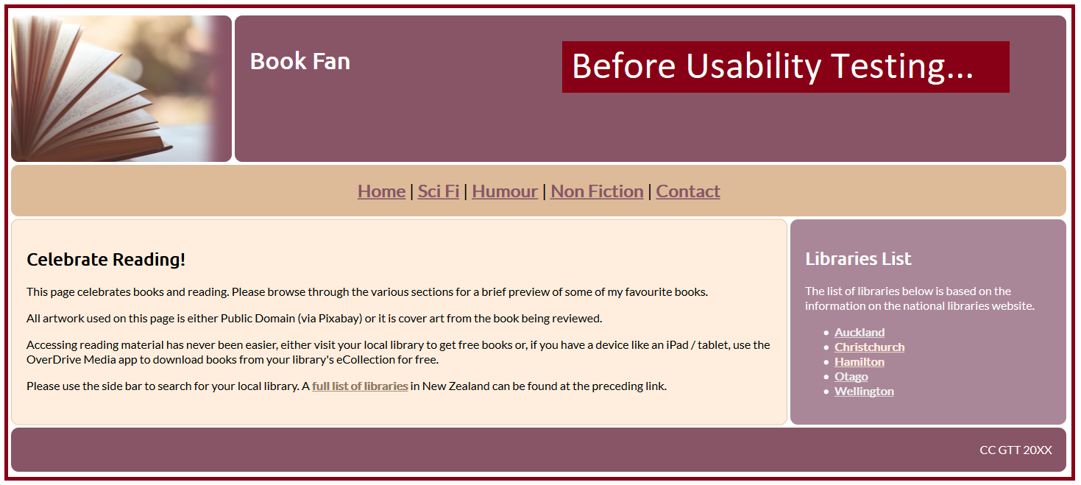

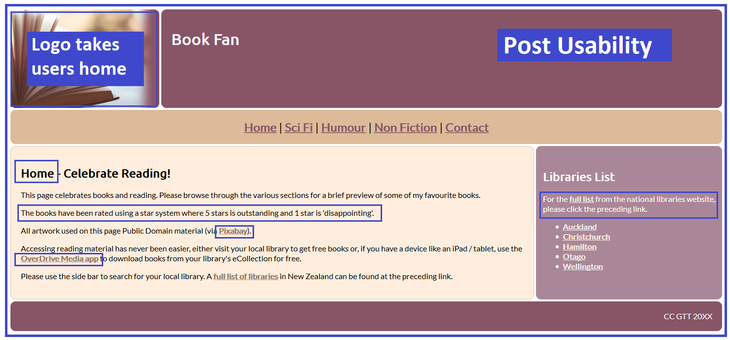

### Accessibility

I checked that my site looked acceptable to colour blind users using an online colour blindness simulator (<http://www.color-blindness.com/coblis-color-blindness-simulator/>)

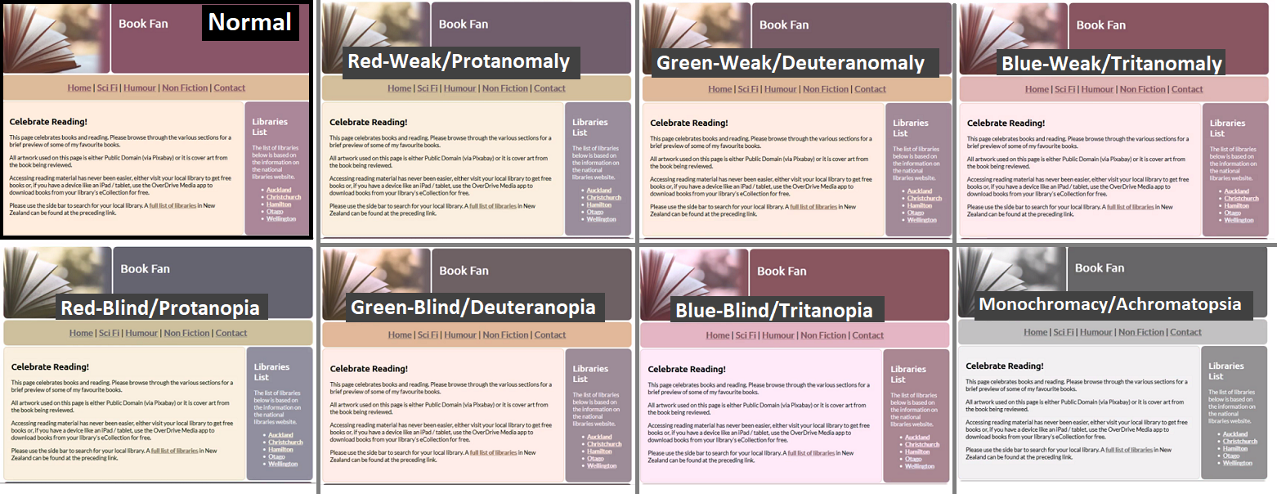

As you can see from the screenshots above, the content is still readable.

In this particular site, most of the images were ‘eye candy’ (ie: they did not add any extra information to the page) so I left the alt text blank. When I made the logo clickable, I added a title to the logo div which states that clicking the logo will take users back to the home page.

### Image Sources

To avoid breaching copyright and save time, I used public domain images from Pixabay. Below is a list of the images that I used in making the site…

<https://pixabay.com/en/blur-blurred-book-book-pages-1283865/> (book at top left of all pages)

<https://pixabay.com/en/art-new-zealand-water-1840136/> (rocks on contact page)

<https://pixabay.com/en/towels-linen-house-bathroom-dry-1470231/> (towel on ‘humour’ page)

<https://pixabay.com/en/iapetus-saturn-astronomy-satellite-2773538/> (saturn on sci-fi page)

<https://pixabay.com/en/question-mark-important-sign-1872665/> (don’t make me think)